
Read Write Inc. Teaching Progression
If children are progressing at expected levels, they will learn the following:

 | Reception | Year 1 | Year 2
Autumn 1 | - Teach Set 1 sounds:  m a s d t i n p g o c k u b f e l sh h r j v w x y z th ch qu ng nk | - Teach Set 2 sounds:  ay ee igh ow oo oo ar or air ir ou oy  - Teach reading of words containing these Set 2 sounds.  - Build speed of reading words containing Set 1 sounds. | - Continue to teach Set 3 sounds  - Teach reading of multisyllabic words containing all sounds.  - Build speed of reading words containing Set 3 sounds.
Autumn 2 | - Recap any single letter alphabet gaps from the sounds above.  - Teach children to blend using single letter alphabet sounds. | - Review all Set 2 sounds  - Teach reading of words containing these Set 2 sounds.  - Build speed of reading words containing Set 1 sounds, particularly WT 1.6-1.7 | - Recap any missing sound gaps and build fluency when reading stories.  - Children should complete the programme at end of Aut 2:  Children can read stories and  passages at a pace of 100 words per minute. They can read all sounds in words, including multisyllabic words, with little or no hesitation.
Spring 1 | - Recap Set 1 Special Friends: sh th ch qu ng nk ck ss ff ll zz  - Secure blending of cvc words using single letter alphabet sounds (WT 1.1-1.5). | - Teach Set 2 sounds, particularly: ar or air ir ou oy  - Teach reading of words containing these Set 2 sounds.  - Build speed of reading words containing ay ee igh ow oo  oo.
Spring 2 | - Recap Set 1 Special Friends: sh th ch qu ng nk ck ss ff ll zz  - Secure blending of words containing these sounds (WT 1.4-1.6). | - Teach Set 3 sounds: ea, a-e  - Teach reading of words containing these Set 3 sounds.  - Build speed of reading words containing all Set 2 sounds.
Summer 1 | - Recap Set 1 sound gaps.  - Teach blending of words containing consonant blends (WT 1.7). | - Continue to teach Set 3 sounds  - Teach reading of words containing these Set 3 sounds.  - Build speed of reading words containing all Set 2 and Set 3 sounds. | Read Write Inc. Spelling
Summer 2 | - Teach Set 2 sounds:  ay ee igh ow oo oo ar or air ir ou oy  - Teach reading of words containing these Set 2 sounds.  - Build speed of reading words containing Set 1 sounds. | - Continue to teach Set 3 sounds  - Teach reading of words containing these Set 3 sounds.  - Build speed of reading words containing Set 3 sounds. | Read Write Inc. Spelling
End of Year Expectations | Children can read all Set 1 sounds and some Set 2 sounds in words, including words with consonant blends. They have built speed of reading some of these words and can read them without  hesitation. | Children can read all Set 1, 2, 3 sounds in words and can read Set 1 and 2 sounds in words at speed. They can read some Set 3 sounds in words without hesitation.  They can read at a pace of 60 words per minute. | Read Write Inc. Spelling
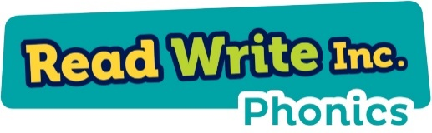



Read Write Inc. Phonics Speed Sounds Progression

Set 1 |  | Set 2 |  | Set 3
Sound | Rhyme | Sound | Rhyme | Sound | Rhyme
m | Down Maisie then over the two  mountains. Maisie, mountain, mountain. | ay | May I play? | ea | Cup of tea
a | Round the apple, down the leaf. | ee | What can you see? | oi | Spoil the boy
s | Slide around the snake. | igh | Fly high | a_e | Make a cake
d | Round the dinosaur’s back, up his  neck and down to his feet. | ow | Blow the snow | i_e | Nice smile
t | Down the tower, across the  tower. | oo | Poo at the zoo | o_e | Phone home
i | Down the insect’s body, dot for  the head. | oo | Look at a book | u_e | Huge brute
n | Down Nobby and over the net. | ar | Start the car | aw | Yawn at dawn
p | Down the plait up and over the  pirates face. | or | Shut the door | are | Care and share
g | Round the girl’s face, down her  hair and give her a curl. | air | That’s not fair | ur | Nurse with a purse
o | All around the orange. | ir | Whirl and twirl | er | A better letter
c | Curl around the caterpillar. | ou | Shout it out | ow | Brown cow
k | Down the kangaroo’s body, tail  and leg. | oy | Toy for a boy | ai | Snail in the rain
u | Down and under the umbrella, up to the top and down to the  puddle | wh | Whisk, whisk | oa | Goat in a boat
b | Down the laces, over the toe and  touch the heel. | ph | Take a photo | ew | Chew and stew
f | Down the stem and drawer the leaves. | kn | Knock knock, who’s  there? | ire | Fire fire
e | Slice into the egg, go over the top  then under the egg. |  |  | ear | Hear with your ear
l | Down the long leg. |  |  | ure | Sure it’s pure
h | Down the horse’s head to the  hooves and over his back |  |  | tion | Pay attention it’s a celebration
r | Down the robot’s back, then up  and curl. |  |  | tious  cious | Scrumptious, delicious
j | Down his body, curl and dot. |  |  | au | Paul the astronaut
v | Down a wing, up a wing. |  |  | ie | Terrible tie
y | Down a horn, up a horn and  under the yak’s head. |  |  | ue | Come to the rescue
w | Down, up, down, up the worm. |  |  | e_e | Go Pete and Steve
z | Zig-zag-zig, down the zip.
x | Cross down the arm and leg and  cross the other way.
sh | Slither down the snake, then down the horse’s head to the  hooves and over his back.
th | Down the tower, across the  tower, then down the horse’s  head to the hooves and over his back.
ch | Curl around the caterpillar, then  down the horse’s head to the  hooves and over his back.
qu | Round the queen’s head, up to  her crown, down her hair and  curl.
ng | A thing on a string
nk | I think I stink
ck | Tick tock clock
ss | Kiss, kiss
ff | Huff and puff
ll | Sell the doll
zz | Fuzz and buzz

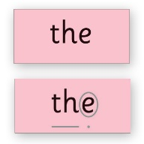
Red sounds represent RWI additional sounds.

Read Write Inc. Phonics Red Words Progression
Red words taught in each storybook colour group.
Key
- Newly introduced Red Words are listed in black
- Red Words that have appeared in an earlier Storybook are in grey
- Red Words with an asterisk next to them are ‘red for a while’ words, i.e. red until the tricky grapheme is taught as a Speed Sound.

Red Ditty Books | Red Words
Red Ditty Book 1 PIN IT ON | put
Red Ditty Book 2 GOT HIM | the I put
Red Ditty Book 3 CAT IN A POT | the no of
Red Ditty Book 4 JAM | I of my the
Red Ditty Book 5 PICK IT UP
Red Ditty Book 6 WUFF WUFF | my I the of
Red Ditty Book 7 LET’S SING | the I of
Red Ditty Book 8 LET’S SWIM | I put the of
Red Ditty Book 9 CLUCK | my the I for*
Red Ditty Book 10 IN THE MUD | I the of my he

Green Storybooks | Red Words listed in the Red Words grid in the Storybooks | Red Words in the story
Green Storybook 1 ON THE BUS | the your put  I he of  my put no  the your he | the your
Green Storybook 2 MY DOG NED | the said I  of my your  he put no  my your said | the I my of said
Green Storybook 3 SIX FISH | you I said of my the your he put no said you | said of you I
Green Storybook 4 THE SPELL | the you I said be of my your he put no be | you said the I my be the of
Green Storybook 5 BLACK HAT BOB | he said no my I you  be of your  the put said | he said my no I
Green Storybook 6 TUG, TUG | he said no I you be the of your my put he | I he said no
Green Storybook 7 CHIPS | I said of no you be  the he your  my put said | of I said no
Green Storybook 8 THE WEB | said the my  are I you your be he  put of no | are my said I the
Green Storybook 9 PIP’S PIZZA | I said the he no you  your be are  my of put | I put the he said no you
Green Storybook 10 STITCH THE WITCH | I the said you of your  be are my  no put he | said the you I of

Purple Storybooks | Red Words listed in the Red Words grid in the Storybooks | Red Words in the story
Purple Storybook 1 KEN’S CAP | the of to no my I  said are your you be put | the of to no I my
Purple Storybook 2  A BAD FOX | I the me go are he  be you your my of put | the me go I put
Purple Storybook 3  BIG BLOB BABY BLOB | the of he baby no to put(s) go be you your are | baby the he put(s) of
Purple Storybook 4  TIM AND TOM | said my are the I no  of go to your you he | are said the I my
Purple Storybook 5  TAG | I said you me your are he put be  of to go | I said you me
Purple Storybook 6 ELVIS | I you the my your are said go of to no be | I the you my
Purple Storybook 7  FLIP FROG AND THE BUG | I to said  the you your no go to  of are he | to said I the
Purple Storybook 8  RED KEN | he of the said paint* I my be he are you your | the of said I paint* he my
Purple Storybook 9 BILLY THE KID | said the I me you no are your he be go of | the me said no I put you
Purple Storybook 10  IN THE BATH | the said are your he be you to go of my me | the said put he your are

Pink Storybooks | Red Words listed in the Red Words grid in the Storybooks | Red Words in the story
Pink Storybook 1 SCRUFFY TED | all my like* I’ve the are said go you your are be to me of he | my the put I’ve like* all
Pink Storybook 2  TAB THE CAT | want you call we be no her are the said your go he I’ve all said | are the we no you be want her call
Pink Storybook 3  IN THE SUN | my of the your all call want no we her he to I’ve are said go | my the of
Pink Storybook 4  THE DRESSING UP BOX | all me you said the be her he call want I’ve to no my your we | you said the all me
Pink Storybook 5  TAB’S KITTEN | he she to no call her I’ve the we me all my  want you your I’ve | the I’ve call(s) to she her no he
Pink Storybook 6 SANJAY STAYS IN BED | of are said you all no he call we put your to want I’ve she go | said no all of are you he
Pink Storybook 7  THE GREEDY GREEN GREMLIN | to my washing* the all I’m he we  she want said I’ve are go no her | I’m the to my washing*
Pink Storybook 8  IN THE NIGHT | some no all of the your her I’ve call me I’m are we he she want | the some of I’m no all
Pink Storybook 9 SNOW | my you to me the she we no  are want some I’m all call your he | me to the you my I’m
Pink Storybook 10  SO COOL! | be the my no so all I’ve she  some want said he you your to her | my no of the all be so

Orange Storybooks | Red Words listed in the Red Words grid in the Storybooks | Red Words in the story
Orange Storybook 1 PLAYDAY | what they do said you to the we want some I’ve all are your go no | said you what do to(day) the they
Orange Storybook 2  I THINK I WANT TO BE BEE | what to me be want my they said are some I’ve we he she her all | want to be what my me
Orange Storybook 3  A BAD FRIGHT | go my what be  the want some said call all to we are you your they | be the my go what(‘s) to(night)
Orange Storybook 4 FOLLOW ME! | said he me you to do what no the your her she all I’ve are go | go the said me do you what to no he
Orange Storybook 5  TOO MUCH! | old my are said me he to do  what no you some want call your all | my are old
Orange Storybook 6  A GOOD COOK? | said all he put my said so to the your what I’ll want old are do | my said I’ll to(ay) put the all he so
Orange Storybook 7 COME ON MARGO! | was to are old so go you they the we said go do my her all | the old go to they was so you are
Orange Storybook 8  MY SORT OF HORSE | so of want all to do my the  was what some your are old they go | of so all the want(s) to my do
Orange Storybook 9 HAIRCUTS | you want do of no the old was  what some are I’ve be he me she | the of do you want no
Orange Storybook 10 MY BEST SHIRT | my said so she we me her to the do old want  some what I’m be | me my said she so we the her I’m to
Orange Storybook 11 LOOK OUT! | want my do to the said he some so she we me  her old what they | want(s) to the my do
Orange Storybook 12 HUNT THE TORTOISE | he be said no so go to all call the we old me she her of | he the call(ed) be said to go we all so no

Yellow Storybooks | Red Words listed in the Red Words grid in the Storybooks | Red Words in the story
Yellow Storybook 1  THE DUCKCHICK | some saw her to all was some they watch of are saw  some said call your you want what saw | some saw her to all was they watch of
Yellow Storybook 2  OFF SICK | watch was to all said want you are of school her they some call what are want said your saw | watch(es) was to all said want you are of school her they
Yellow Storybook 3 TOM THUMB | small was to do said of what small their do all was  what your saw watch they are school me | small was to do said of what their
Yellow Storybook 4  THE GINGERBREAD MAN | to was her said you you of was  they their was want some small all are were do school what | to was her said you of they their
Yellow Storybook 5 ROBIN HOOD | your who tall you of to want they said call all one was are your do  want some who school | your you of to want they said call all one was are who tall
Yellow Storybook 6 LOST | they call all are your you her what do to brother of were are they was  who school want some | they call all are your you her what do to brother of were
Yellow Storybook 7  DO WE HAVE TO KEEP IT? | want all one to do you I’m I’ve baby was were of  one they your call what school said are | want all one to do you I’m I’ve baby
Yellow Storybook 8  DANNY AND THE BUMP-A-LUMP | there watch small what some of was to  watch you I’ve I’m all are there school call were said they | there watch small what some of was to you I’ve I’m all
Yellow Storybook 9  GROW YOUR OWN RADISHES | their you your want some they are small of fall* call any  to school were they what watch there all | their you your want some they are small of call any to fall*
Yellow Storybook 10 THE FOOLISH WITCH | where some they was you said to were there are tall call wall* of school any their want watch what | where some they was you said to were there are tall call wall* of

Blue Storybooks | Red Words listed in the Red Words grid in the Storybooks | Red Words in the story
Blue Storybook 1  BARKER | does were all one said of to they were some any was want are where you  your watch there their | does were all one said of to they
Blue Storybook 2  THE POOR GOOSE | any other two one all her there said were I’m to watch your does their they want was are any | any other two one all her there said were I’m to
Blue Storybook 3  HAIRY FAIRY | could there all they any I’m I’ve to what do ball watch said call could  were one two other their | could there all they any I’m I’ve to what do  ball
Blue Storybook 4  KING OF THE BIRDS | would want their watch some there said all water were they are to was one wash* you would any could | would want their watch some there said all water were they are to was  one wash* you
Blue Storybook 5  OUR HOUSE | anyone over who all one watch does they school you to were was said wasn’t want water some their there | anyone over who all one watch does they school you to were was said wasn’t
Blue Storybook 6  THE JAR OF OIL | through once there son there who your her was to you of one all over anyone does school any said | through once there son who your her was  to you of one all
Blue Storybook 7  JADE’S PARTY | brother all where said one was you of any son over does school once school there who are your watch | brother all where said one was you of
Blue Storybook 8 JELLYBEAN | any what one was want does could said some of who brother there their I’m could all who where two | any what one was want does could said some of
Blue Storybook 9  A BOX FULL OF LIGHT | all who there their could some of was they to said saw what does any  once want where one are | all who there their could some of was they to said saw what
Blue Storybook 10 THE HOLE IN THE HILL | whole want your any could what their was small tall all of to you were does people one  are want | whole want your any could their was small tall all of to you were people

Grey Storybooks | Red Words listed in the Red Words grid in the Storybooks | Red Words in the story
Grey Storybook 1  REX TO THE RESCUE | should were there call want come could one through was you to said all of through any some does are | should were there call want come could one through was you to said all of through
Grey Storybook 2  THE LION’S PAW | many could one are were other through was call to there they  said all does want what come any should | many could one are were other through was call to there they said
Grey Storybook 3  I DARE YOU | two there who were you said your one could what was school to of all should  want does through many | two there who were  you said your one could what was school to  of all
Grey Storybook 4  LOOKING AFTER A HAMSTER | mother are you want to one your they come other of water school many there their some could should through | mother are you want  to one your they come other of water
Grey Storybook 5  HOW SILLY! | above father son mother some here who there people water was to  you all what come they were one should | above father son mother some here who there people water was to  you all what come they were one
Grey Storybook 6  WAILING WINNY’S CAR BOOT SALE | buy bought do some to of said you bought some what father mother son here come could should through any | buy bought do some to of said you
Grey Storybook 7  TOAD | father one watch should there come said who anyone whole water was ball of what your could said you were | father one watch should there come said who anyone whole water was ball of what your could you were
Grey Storybook 8  ANDREW | great brother above where could was what here someone through another there school water of  were to all one want | great brother above where could was what here someone through another there school water of  were to all one
Grey Storybook 9  DEAR VAMPIRE | walk said they were was what small are any here son who would there to you all great above through | walk said they were was what small are any here son who would there to you all
Grey Storybook 10  VULTURE CULTURE | one some their where they many are were  come two of above where there walk here any through who other | one some their where they many are were come two of above
Grey Storybook 11 CELEBRATION ON PLANET ZOX | caught worse come call was said their great everyone should who here watch all they of  you were there another | caught worse come call was said their great everyone should who here watch all they of  you were there another
Grey Storybook 12  A VERY DANGEROUS DINOSAUR | talk thought there where all through one would two was they other  were caught worse what want their great should | talk thought there where all through one would two was they other
Grey Storybook 13  THE INVISIBLE CLOTHES | love wear some could buy bought thought everyone father any whole one you said was through there they were walk | love wear some could buy bought thought everyone father any whole one you said was through there they were walk

RWI Phonics Groups and what they mean:

Group | I can… | I am learning to…
Set 1A  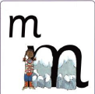  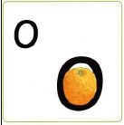 | Recognise some single letter sounds | Recognise all single letter sounds.  Orally blend sounds
Set 1B | Recognise most or all single letter sounds | Orally blend sounds  Blend sounds to read short words e.g. cat, box, tin
Set 1C  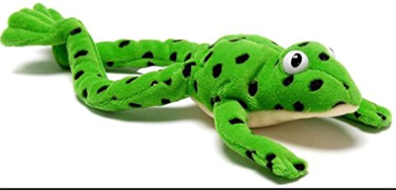  m-a-t | Recognise most or all single letter sounds | Blend sounds to read short words e.g. cat, box, tin
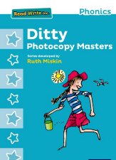  Ditties | Read 2 or 3 sound words independently (am, red, bin) | Recognise the Set 1 digraphs (‘Best Friends’) and read them in words:  sh ch qu ng nk th ck  ss ff ll zz
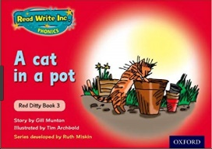  Red books | Recognise the Set 1 digraphs (‘Best Friends’) and read them in words. | Read words with 4 and 5 single letter sounds:  stop jump stamp crept  Read words with 3 sounds speedily:  man got sit
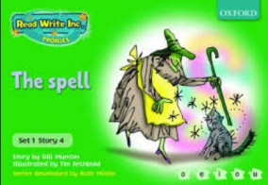  Green books | Read words with 4 and 5 single letter sounds | Read the first 6 Set 2 sounds and in words:  ay ee igh ow oo oo  Read words with 3 sounds that contain a digraph speedily:  this chip quiz
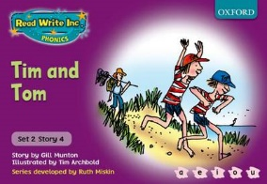  Purple books | Read words with 4 and 5 single letter sounds | Read the first 6 Set 2 sounds and in words, including some multisyllabic:  ay ee igh ow oo oo  Read words with 4 and 5 sounds speedily:  stop jump stamp crept

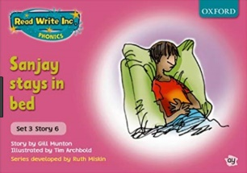  Pink books | Read the first 6 Set 2 sounds and in words, including some multisyllabic:  ay ee igh ow oo oo  Read words with 4 and 5 sounds speedily:  stop jump stamp crept | Read the next 6 Set 2 sounds and in words, including some multisyllabic:  ar or air ir ou oy  Read word with the first 6 Set 2 sounds speedily:  play night sleep about
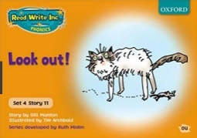  Orange books | Read the next 6 Set 2 sounds and in words, including some multisyllabic  ar or air ir ou oy  Read word with the first 6 Set 2 sounds speedily  play night sleep about | Consolidate Set 2 sounds  Read the first six Set 3 sounds and in words, including some multisyllabic  ea oi a-e i-e o-e u-e
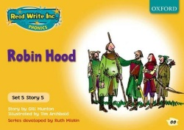  Yellow books | Read the first six Set 3 sounds and in words, including some multisyllabic  ea oi a-e i-e o-e u-e | Continue reading Set 3 sounds and in words, including some multisyllabic.  Build speed for reading whole texts (60-70 wpm)
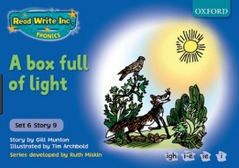  Blue books | Read Set 3 sounds and in words, including some multisyllabic.  Can read whole texts at 60-70wpm | Continue reading Set 3 sounds and in words, including multisyllabic with growing speed  Build speed for reading whole texts (70-80 wpm)
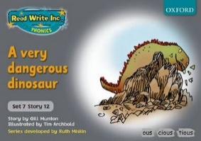  Grey books | Can read Set 3 sounds and in words, including multisyllabic with growing speed  Can read whole texts at 70-80 wpm | Continue reading Set 3 sounds and in words, including multisyllabic with speed  Build speed for reading whole texts (90-100+ wpm)

