Great Ponton CE Primary School

SEN(D) Information Report
2026 & 2027


Item | Date
Approved by Governors | 15.9.26
Review Date | September 2027
SENCo | Amanda McDonnell
Headteacher | Keith Leader
SEND Governor | Bronwyn Hedley

Introduction
At Great Ponton School, we have high expectations and offer excellence and choice for all our children, whatever their abilities or needs. We aim to achieve this through the removal of barriers to learning and participation for all. We ensure that all our children know that they are valued and important members of our community and through appropriate curricular provision, we respect the fact that children:
- have different educational and behavioural needs and aspirations;
- require different strategies for learning;
- acquire, assimilate and communicate information at different rates;
- need a range of different teaching approaches and experiences.

We aim to meet the needs of each and every child, including those with Special Education Needs and Disabilities, so they reach their full potential and enjoy their learning.

Our SENCO is:
SENCo: Amanda McDonnell
Email: Amanda.mcdonnell@greatponton.lincs.sch.uk or enquiries@greatponton.lincs.sch.uk
Telephone: 01476 530306

How does Great Ponton School know if our pupils need extra help?
A child has special educational needs if she or he has a:
- Learning difficulty which is significantly greater than the majority of children of the same age
- Disability which makes it difficult to use the facilities normally available

Special educational needs are described by the Special Educational Needs Code of Practice as falling into four areas. These are:
- Communication and interaction
- Cognition and learning
- Social, Emotional and Mental Health
- Sensory and/or physical.

There are several different circumstances which may lead to the suggestion of special educational needs.

- You may feel there has been a problem of some kind for a while, though you may not be able to identify what that problem is.
- A difficulty may have been suggested by a health visitor, doctor or other health professional.
- Your child’s class teacher may speak to you with concern about your child’s progress, or with a specific difficulty.
It is very important that parents and school work together, so if you have any concerns, please make an appointment to speak to your child’s class teacher, just as he/she will contact you for an appointment if he/she has any worries.
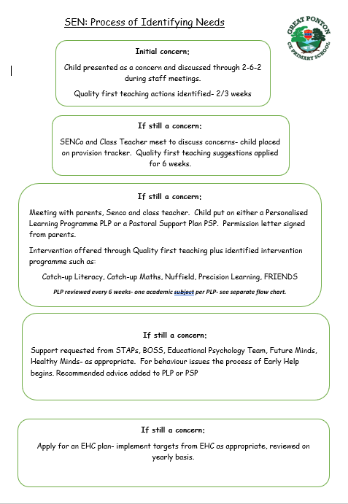
What should I do if I think my child has Special Educational needs (SEN)?

If I think my child has special educational needs, how do I get a diagnosis for my child?
Pupils will only receive a diagnosis if they have a specific learning difficulty such as a risk of Dyslexia, or have a medical need. Pupils do not receive a 'diagnosis' of special educational needs. The SENCo, in consultation with the class teacher and parent, will identify that a pupil has a difficulty which is preventing them from learning in the same way as their peers and will place them onto our SEND Register.

If you are concerned that your child has a specific difficulty such as ADHD or Autism, the SENCo, with parental permission, can make a direct referral to the Community Paediatrician. If the referral is accepted, you will receive an appointment with a paediatrician, who will give you further information and an assessment may begin.

If you are concerned that your child has a learning difficulty such as Dyslexia, the SENCo can make a referral to a Specialist Teacher. She can identify if a pupil has difficulties consistent with Dyslexia and will provide a risk scaling diagnosis and provide advice about how best to support their needs.
If you are concerned that your child has a speech and language difficulty, the SENCo, with parental permission, can make a referral to the 'Speech and Language Therapy Service' (SALT). A therapist may then assess and identify if a pupil has a specific speech and/or language difficulty and provide advice about how best to support their needs.
How long does a diagnosis/referral take?
Referral time can vary depending upon the agency involved. Referrals to the NHS (Community Paediatrics and Speech and Language Therapy Service) take considerably longer, on average it can take up to 20 weeks to receive an appointment. Not all pupils will receive a diagnosis and/or decision. Where diagnoses are made, this can take a considerable time depending upon the individual. In many cases, a diagnosis follows several appointments, which could take more than a year.
Referrals to the Specialist Teacher are made within the school and are dependent on how many referrals have been made at that point. This can take anything from two weeks to a whole school term. Where the Specialist Teacher identifies a specific difficulty this will take approximately two weeks once the assessment has been completed.

What happens once a diagnosis has been made?

At School we do not wait to put support in place. If it is very clear that a pupil has difficulty and is struggling to learn, we will do everything that we can to help them whether they have a diagnosis or not.
If a diagnosis is made, we will ask for advice from the relevant outside agencies about how best to help the pupil. This advice will then inform the pupil's Personal Learning Plan (PLP) and be shared with you and/or discussed at a meeting. We will put this advice in place straight away or once the relevant resources/equipment have been purchased.

What will school do to support my child?
Initially we will implement the agreed plan of action, making full use of the support available within the school. Where necessary additional advice and support may be sought from external agencies. Personal Learning Plan (PLPs) will include agreed strategies and interventions that will be in place to support the child as well as realistic short term SMART (Specific, Measurable, Achievable, Relevant/Realistic, Time-bound) targets. These will be reviewed through the graduated approach and following the cycles of ‘Assess, Plan, Do, Review’.
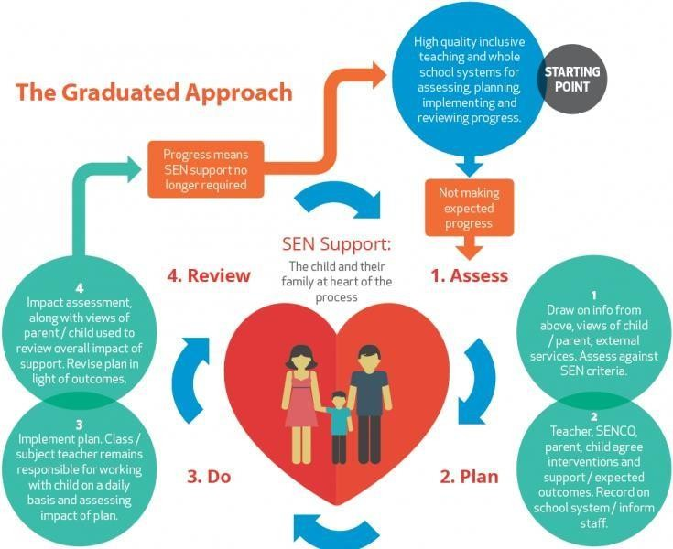
Who will support my child in school?

There are many individual and groups of people (detailed below) who may be involved in providing support for your child.

Who? | Roles & Responsibilities
Class Teacher | The Class teacher has overall responsibility for your child’s progress and will work with you and your child to ensure his/her needs are met. The Class teacher is the first point of contact should you wish to raise a concern about your child.
SENCo | The SENCo will monitor the progress of all the children on the SEN register and will monitor the effectiveness of intervention for children throughout the school. The SENCo will lead review meetings, refer children to outside agencies when appropriate, liaise with other professionals and complete relevant paperwork.
Headteacher | The Head Teacher is in overall charge of all staff in school. The Head Teacher leads the termly pupil progress meetings and ensures that provision and support is available for children with SEN. The Head Teacher meets regularly with the SENCo to discuss provision in school
Teaching Assistants | The Teaching Assistants support teaching and learning on a daily basis and have excellent knowledge of the children. They work with children 1:1 as well as in small groups and also deliver structured interventions with the guidance of the class teachers and SENCo.
Midday Supervisors | The Midday Supervisors support the social, emotional and mental health (SEMH) needs of pupils and their positive engagement with school life. Good communication between teaching staff and Midday Supervisors ensures that children are closely monitored during lunchtime and information is passed on if
Administrators | The Administrator will add your child’s special educational need to  the central record and provide clerical support when needed.
SEN Governor | The Governing Body of Great Ponton CE Primary School has a named Governor whose responsibility is to oversee the provision for SEN and feed information back to the governors
Outside Agencies | The School works with a range of Outside Agencies including Speech and Language Therapists, Specialist Teachers, Educational Psychologists, Physiotherapists, Paediatricians and outreach services. Their role is to support the child, family and school with all aspects of  SEND.

What experience and qualification does the SENCo have?
In line with the SEN Code of Practice (2014) the SENCO is a qualified teacher, who holds a National Award in Special educational Needs Co-Ordination. In addition the SENCo attends local SEN Cluster Group meetings, and other training or briefing meetings provided by the Local Authority.
What training does the staff have (in relation to SEND)?
All staff within the school have regular training in a wide range of safeguarding and special educational needs and disability areas
This may be specific to job roles or training carried out by the whole staff.

What support will there be for my child’s emotional and social well-being?
At our school, we are committed to supporting the social, emotional and mental health (SEMH) needs of all pupils, including those with Special Educational Needs and Disabilities (SEND). Our pastoral provision is designed to ensure every child feels safe, understood, and ready to learn. We offer a graduated and flexible approach, tailored to individual needs, through a range of targeted interventions and universal support systems.
Our pastoral provision The Ark – Sensory Room is our dedicated sensory space, The Ark, provides a calm and supportive environment for pupils who may feel overwhelmed or dysregulated. It is equipped to support sensory processing needs and emotional regulation.
We have trained ELSA staff who deliver structured support to pupils experiencing emotional difficulties. Sessions focus on areas such as self-esteem, social skills, emotional awareness, and coping strategies. We can offer Drawing and Talking Therapy, this therapeutic intervention allows children to process emotions and experiences in a safe, non-intrusive way through drawing. It supports emotional healing and promotes mental wellbeing. We can offer Lego-based therapy is used to develop communication, teamwork, and social interaction skills in a structured and engaging way, particularly beneficial for pupils with social communication needs.
We recognise that every child is unique. Therefore, we design personalised pastoral interventions tailored to individual needs, which may include small group work, 1:1 sessions, or targeted support plans. Pastoral provision is regularly reviewed to ensure it is effective and responsive to pupils’ needs. Staff work closely with families and, where appropriate, external professionals to secure the best possible outcomes. Pupils demonstrate increased confidence, improved emotional regulation, and greater readiness to learn over time. The school’s inclusive ethos ensures that pupils with SEND are supported to participate fully in school life. The school’s pastoral offer aims to remove barriers to learning by supporting pupils’ emotional wellbeing. Through early identification and targeted intervention, pupils are enabled to achieve well and develop the skills needed for future success.

Teachers, Teaching Assistants, Pastoral Lead and Midday Supervisors build up strong relationships with children to support their emotional needs.
- The school rules, including rewards and sanctions, are used consistently to support children’s behaviour.
- We work closely with outside agencies to support pupils with social, emotional and mental health (SEMH) needs.
- All safeguarding and child protection issues will be reported via CPOMS to Keith Leader (Head Teacher and Designated Safeguarding Lead), Amanda McDonnell (Deputy Designated Safeguarding Lead and SENCo).
- PSHE is considered an important subject taught weekly and the Jigsaw PSHE Scheme of Work is used across the whole school.
- Some staff members are trained in ‘Drawing and Talking’ and ELSA. These may be used to support children on a regular basis for a length of time, alongside outside agencies when needed.

My child has special educational needs and/or disability (SEND), what extra support could you provide and who will decide on the support?
This will depend upon your child's individual needs. Each child's needs are unique and so each child will receive different support, depending upon their specific needs. The Special Educational Needs Co-ordinator (SENCo) and class teacher will decide which strategies and resources are appropriate to support your child's needs. Where outside agencies are involved, they will provide advice about how best to support your child's needs. Special Educational Needs (SEN) are divided into four areas. Below are some examples of what the federation can provide.
Cognition and Learning (Learning Need)
- Different approaches to learning, e.g. visual, hands-on
- Different work expectations, matched to the child's ability
- Different/extra resources, e.g. word cards, number squares
- Special Literacy or Numeracy programmes,
- Extra adult support, group work, individual support

Communication and Interaction (Speech and Language)
- Resources provided by the Speech and Language Therapy Service - First Call
- Communication and language games
- Social skills games
- Specific Speech and Language programmes provided by the Speech and Language Therapy Service

Social, Emotional and Mental Health (SEMH)
- ELSA strategies
- Social skills games
- Reward strategies
- Playground buddies
- Social Stories
- Lunchtime clubs

Sensory and Physical Needs
- Specialist equipment such as seating, writing slopes, pencil grips and calmers
- Specialist training from outside agencies, such as physiotherapists for pupils with disabilities
- Sensory Circuits to meet the individual sensory needs of a child

What if my child has Medical needs?

If your child has specific medical needs then please contact either your class teacher or the SENCo so appropriate plans can be put into action. If needed, a ‘individual care plan’ can be developed, with support and advice from outside agencies, to inform all staff of the specifics of the condition and what should be done to support the needs of the child. If your child requires ongoing medication, please contact the school office for more information.

What if my child requires support with their social, emotional and mental health (SEMH) needs, including attendance and behaviour?

If your child needs support regarding behaviour they may have a personal learning plan or a personal support plan. The support provided will follow the same Assess, Plan, Do, Review process (as outlined on page 2).

How will my child be involved in the process and be able to contribute their views?

Your child will be involved in the process of ‘Assess, Plan, Do and Review’ through talking to familiar adults about his/her work, identifying his/her strengths as well as aspects he/she finds tricky. This often involves sharing classroom work and attending review meetings if appropriate.

How will the curriculum be matched to my child’s needs?

All children are well supported within the classroom by highly skilled teachers and teaching assistants. Appropriate adjustments are made to the classroom, teaching and resources to ensure that all children have access to the curriculum. These include:
- a clearly differentiated curriculum;
- collaborative learning (talking partners, mixed ability group work);
- using ICT or a scribe to record;
- using ICT to support learning;
- using drama techniques;
- using concrete apparatus (numicon, magnetic letters);
- the use of pupil’s interests;
- targeted group work;
- pre-learning of key points or vocabulary prior to a lesson;
- 1:1 support;
- 1:1 teaching;
- interventions and guided work;
- high quality phonics teaching;
- the use of visual aids;
- adaptation of the learning environment.

What opportunities will there be for me to discuss my child’s attainment and achievement and how will I know how well my child is progressing?
We pride ourselves on our positive relationship with parents. The School operates an open
door policy so if you have any questions about your child’s progress you can make an appointment to see your child’s class teacher at any time. We report in detail to parents through Parents’ Consultation Evenings in October and March and via the School Report in July. We also hold Parent Drop in sessions for the parents of children who are on the SEN register. These are usually around the time of the parents evenings and are held as occasionally more time is needed with a teacher in regards to a child with SEN. Permission will always be sought before your child is assessed by an outside agency, e.g. the Specialist Teaching Team, and feedback will be given as a written report or verbally as part of a review meeting. Staff also love to share successes on an as and when basis so will often catch parents at the beginning or end of the day to celebrate individual children’s achievements or progress. There are also numerous occasions throughout the year when parents are invited in to school to see the children working and performing e.g. Open Evenings, Sports Day, Church Services and Celebration Assemblies.

How does the school know how well my child is doing?

On entry to the Early Years Foundation Stage (EYFS), teachers carry out baseline assessments using information from previous settings, discussions with parents, observations and assessment materials aligned to the EYFS Framework and Development Matters guidance In Key Stage One and Two, children’s progress is tracked termly and measured against age- related expectations in relation to the National Curriculum. This process includes Pupil Progress Meetings between the class teacher, Headteacher/SENCo when children’s progress is discussed in relation to directing support and interventions appropriately.
Teacher assessment takes place throughout Key Stage 1, with statutory assessments and teacher assessment used to monitor progress. National assessments take place at the end of Key Stage 2.
Assessments made by outside agencies are also utilised within the School.

How will my child be included in activities outside the classroom, including trips?

The school will endeavour to ensure that provision is put in place so that all children can access after school activities, after school clubs, outdoor learning and educational visits including residential opportunities. Where necessary, we will ensure that specialist support is available and if required, reasonable adjustments made to enable all children to access the provisions on offer, wherever possible.

How accessible is the school environment?

The school site is predominantly accessible at ground-floor level and includes an accessible toilet. Due to the nature and size of the site, dedicated disabled parking is limited. However, Great Ponton CE Primary School is committed to inclusion and will always consider reasonable adjustments to support pupils, parents, carers and visitors with disabilities wherever possible.

How will the school prepare and support my child to join the school?

If your child is joining our school into the Reception class, we have a transition programme in place. Initially your child’s teacher will visit him/her in his/her early years setting (or at home if your child does not attend an early years setting). This is followed by 3 school visits during the Summer Term aimed at helping your child to become comfortable in his/her new surroundings. The children also receive their own Welcome pack which parents can share with them at home in preparation for the new term. If your child joins the school in another year group, we plan, in consultation with parents/carers, the transition depending on the needs of the child. Your child is welcome to make visits to the school to meet their class and their teacher and familiarise him/herself with the school routines.
As with most things in school, these arrangements are extremely flexible and can be personalised and adapted to meet the particular needs of your child. There are also a number of set opportunities for parents to meet with staff in year group and 1:1 settings but again, further meetings can be arranged if necessary.
If a child is already identified as having special educational needs, it is usual practice for our SENCo to be invited to and attend a Nursery review meeting and for all paperwork to be forwarded to the school during the summer break.

How will the school prepare and support my child to transfer to a new setting?

We are committed to working in partnership with professionals and families to ensure smooth secondary or alternative school transition. This usually means communication with the school, planned school visits, transition visits and sharing of key information, usually in Year 5 and Year 6. Additional individualised transition days and booklets can be organized and produced dependent on the needs of individual children. The new school SENCo
attends review meetings and meets with our teachers to discuss each child’s profile and share any relevant information that will help your child experience a smooth transition. All paperwork is kept up to date and forwarded to the new school promptly.

How can I be involved in supporting my child?

You can support your child by:
- engaging with the school;
- attending meetings;
- keeping the school up to date with any changes or information you feel is necessary to pass to the class teacher or SENCo;
- attending parent workshops and open-school events;
- supporting them with reading, spelling, times table and homework tasks;
- providing home and wider learning opportunities
Who can I contact for further information?
If you require any further information, help or support, please contact a member of our school team.

- Your Child’s class teacher
- SENCo – Mrs Amanda McDonnell.
- SEN&D Governor – Bronwyn Hedley
- Headteacher – Mr Keith Leader

How do the school manage complaints in regards to SEND?

We hope that complaints about SEND provision will be rare; however, if there should be a concern the process outlined in the school’s Complaints policy should be followed.

What is the ‘Local Offer’?
The Lincolnshire County Council Local Offer can be found at: http://www.lincolnshire.gov.uk/parents/support-and-aspiration/

This contains information regarding the SEN provision across the county.

How can I access support for myself and my family?
School staff are always available to offer support and signpost to other organisations when necessary. Some useful organisations include:
Organisation | Telephone | Website/Email
Kids |  | www.kids.org.uk – working with disabled children, young people and their families
Young Minds |  | www.youngminds.org.uk
ipsea |  | www.ipsea.org.uk  IPSEA stands for Independent Parental Special Education Advice
Lincolnshire County Council |  | www.lincolnshire.gov.uk – provides information on the local offer, local schools and information for parents including links to support groups. Find links here for 4all – a magazine with up to date information on SEND and activities for children, young people and families. Also find links here for short  breaks for children and young people with
Lincolnshire County Council Support and | 01522  782030 | http://www.lincolnshire.gov.uk/parents/supp ort-and- aspiration/
Liaise Lincolnshire (SENDIASS). | 0800 195 1635 | Free, confidential and impartial information, advice and support for children and young people with SEND and their families  Website: www.liaiselincolnshire.org.uk
Coram Family Lives | 0808 800  2222 | (formerly Parentline Plus)  Confidential advice and support for parents and carers.  Website: www.coramfamilylives.org.uk
PAACT  (Autism) |  | https://www.pactforautism.org.uk/
Lincolnshire ADHD  Support | 01522  539939 | https://lincolnshire.icb.nhs.uk/adhd-pathways-and-support/
EMC Services Equality for Minority | 01427  787190 | emc_lincs@lincolnshire.gov.uk
Family Action | 01522 | lincoln@family-action.org.uk
Lincolnshire Centre Grief & | 01522  546168

