Teaching and Learning Policy

Great Ponton CE Primary School



Approved by governors: | September 2026
Last reviewed on: | July 2026
Next review due by: | July 2027

Aims and Purpose

We recognise that any attempts to further raise standards at Great Ponton Church of England Primary must be focused upon the quality of teaching and learning in the classroom. Continued and sustained improvement is dependent upon improving the quality of teaching and learning that is taking place on a daily basis. Across our school the expectation is that all pupils are provided with high quality learning experiences that lead to consistently high levels of achievement for all pupils. The aim of this document is to help the teachers in the school become the most effective practitioners they can be by using principles established from evidence based best practice research, cognitive science and experience.

By adopting a whole school approach to teaching and learning across our school, we aim:

- to ensure consistency of teaching and learning in each classroom and enable teachers to teach as effectively as possible
- to create effective learning environments to support and facilitate pupils learning
- to give children the skills they require to become effective lifelong learners
- to learn from each other, through the establishment of an enquiry based approach to teaching and learning and a culture where opportunities for sharing good practice are in place
- achieve deep understanding, by helping children connect new knowledge with existing knowledge so they are fluent and unconsciously competent at applying their knowledge as skills
- deliver academic excellence and secure knowledge into long-term memory through developing secure schemas with connected networks of ideas
- enable children to become confident and interested learners, actively engaged in their own learning
- develop children’s self-respect and respect for the cultures and values of others
- develop our learning values: curiosity, compassion, courage and community.
- Within the Early Years Foundation Stage, teaching and learning is delivered through a balance of direct adult-led teaching, high-quality interactions, continuous provision and purposeful play. These approaches support the development of children's knowledge, skills, language and independence whilst reflecting the principles outlined in this policy.

Leaders recognise that staff are at different stages of their professional journey. During 2026-27, implementation will be phased and supported through ongoing professional development, coaching and feedback. Monitoring will focus on identifying strengths and supporting development rather than evaluating compliance against the entire policy.

Implementation and Professional Development

At Great Ponton CE Primary School, we recognise that excellence in teaching is achieved through ongoing professional development, coaching, collaboration and reflection.
This policy outlines our shared vision for effective teaching and learning. The implementation of this vision will be supported through a structured programme of professional development, including:

- Whole-school training.
- Instructional coaching.
- Peer observations and modelling.
- Professional dialogue.
- Subject leader development.
- Opportunities for feedback and refinement.

We recognise that improvement is a journey and that consistency develops over time. Leaders will work alongside staff to develop confidence and expertise in the approaches outlined within this policy.
The purpose of monitoring is therefore to support professional growth, celebrate effective practice and identify areas where further development may be beneficial.

Teaching and Learning Priorities 2026-27

During 2026-27 our professional development programme will focus upon:

- Adaptive Teaching
- High-quality Questioning
- Effective Retrieval Practice
- Developing Oracy

Leaders recognise that embedding these approaches takes time and staff will receive training, coaching and support throughout the year.

Teaching and Learning strategies

Developing the Core 10
During the academic year, staff training, coaching and professional dialogue will be structured around the Core 10 principles.
Leaders recognise that mastery develops over time and staff will be supported in progressively embedding these approaches within their classroom practice.
We have agreed a Planning Framework that encompasses the Rosenshine’s Principles of Instruction.
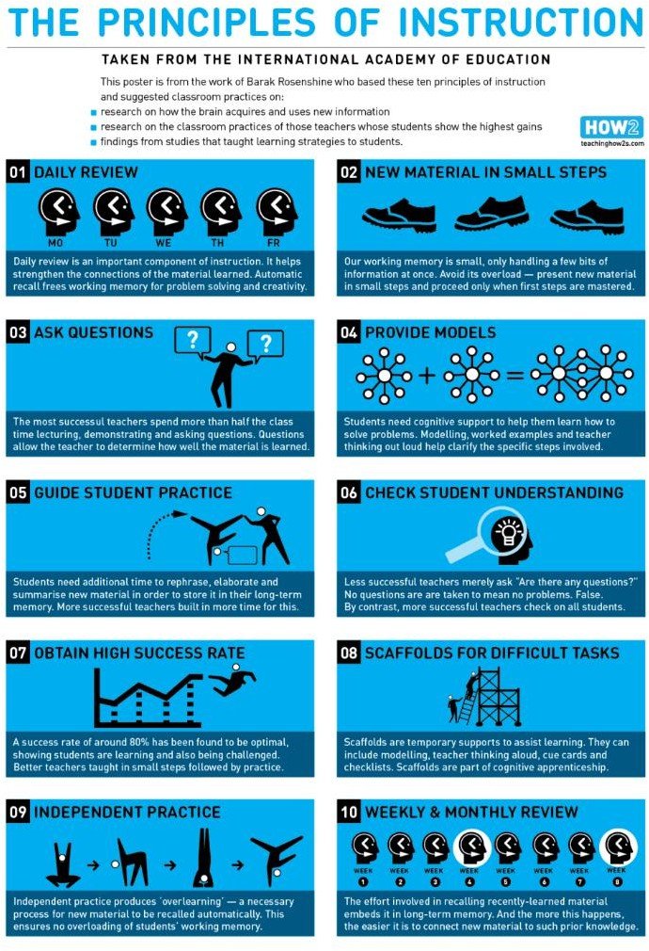

At Great Ponton, we strive to have the following elements in our lessons:

- A daily review of previous learning using retrieval practice strategies.
- New material presented in small steps, with teachers ensuring that each step is mastered before moving on.
- Teachers asking a variety of open questions, and using a range of questioning techniques, to establish children’s understanding.
- Teachers model clearly, using equipment, visual and/or other aids to show children how to solve problems.
- Time for children to do guided practice.
- Teachers check all children’s understanding in a variety of ways.
- Children have a high rate of success, with enough mistakes to show that they are being challenged.
- Scaffolds are provided for all.
- Children are given opportunities to practice independently.
- There are regular reviews of learning.
- High expectations of oracy. Children are expected to answer in full sentences.

These classroom practices are captured through our ‘Core 10’ principles of practice which can be found in the appendix. They underpin all elements of our classroom practice to ensure consistency in teaching and learning approaches across the school.

A detailed guide to our lesson structure at Great Ponton Primary
Effective lessons are typically characterised by four key phases. Teachers may adapt these phases according to the age of pupils, subject content, curriculum requirements and the context of learning. The phases provide a common framework for effective teaching whilst recognising the importance of professional judgement.

- Phase One: set the scene, place learning in a wider context, review and retrieve prior learning; review previous lesson; share intended learning outcomes.
- Phase Two: explaining and introducing new learning in small chunks and providing rehearsal time for pupils
- Phase Three: Time for pupils to complete guided or independent practice
- Phase Four: Review learning and plan next steps

Precise interpretation of the four phase structure will inevitably be very different in different situations. Age, ability, timing of the lesson, subject area and the particular focus for the lesson will all have a significant impact. Teachers may well scroll through the phase more than once during the lesson. The phases are not always sequential. Review, for example, is not confined to the end of the lessons.
Phase One – Review and retrieve prior learning

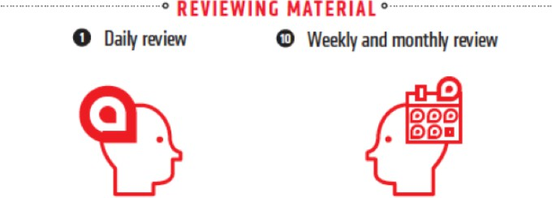

Evidence shows that lessons should include some recall of previous learning – not just of recently learned information, but also of information that was learned much earlier. This helps to build and strengthen the schema of knowledge in the child’s mind, enabling new information to be understood, stick more easily and for longer. For knowledge to be used and applied in the long term memory, knowledge needs to be retrieved. It is vital that children are asked to search their memory for prior learning and then apply this knowledge in their learning.

At Great Ponton, we ensure we plan for lots of low stakes retrieval practice. This does not have to be all and only quizzes. Other strategies encouraged are: Cops and Robbers, Retrieval tennis, Retrieval rockets, Retrieval relays or use retrieval challenge grids structured talk happening. See Appendix 2.
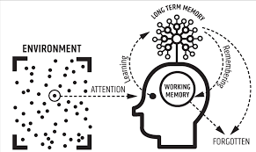

Phase Two – Explaining and introducing new content and providing opportunities to rehearse

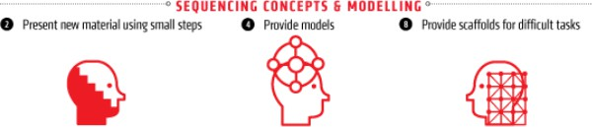

Providing Pupils with new Information or Skills
This is the teaching phase. Although it is our intention for pupils to understand the information as they encounter it, the emphasis within this phase is upon providing new content in small chunks The quality of the input at this stage will clearly have a large bearing upon the extent to which the children understand information that they are given. We aim to achieve this through teaching skills in sequential parts with regular opportunities for children to rehearse and discuss their learning (Core 10 – Sequencing). At Great Ponton Primary we use a range of techniques to try to ensure that the input is of high quality on a daily basis.

High-leverage teaching techniques:

Pre-teach some key vocabulary (Core 10 – Vocabulary)
We recognise that children need to be secure in their understanding of key vocabulary in lessons before we expose them to the vocabulary in texts.
We provide opportunities through teaching for children to practise saying the words, in different contexts, before we expose them to the vocabulary in wider reading. Through fast-paced questioning, we check that all pupils are really secure in these words so that they will recognise the word quickly and interpret the sentences within texts more easily.

Pupils need to hear you say the words.(Core 10 – Oracy)
We recognise that it’s important to pronounce new words clearly and carefully, ensuring all pupils are listening. We ensure that through teaching, we say them in different contexts – not just with definitions but in varied sentences which model their flexible and interesting use.
If a tricky word has many syllables, we sound each syllable out in their choral response, until they get faster with saying it accurately and until they enjoy saying it accurately.

Pupils need to hear themselves say the words (choral response). (Core 10 – Oracy and vocabulary)
When pre-teaching some selected vocabulary before pupils encounter it in text, we understand the importance of providing opportunities for all pupils to say it together, several times, in differing contexts. This is fun, powerfully inclusive, and keeps the lesson pacey.
We aim to get all pupils to say it together, several times, in differing contexts.

Periods of input are short (Core 10 – Sequencing)
We recognise that children have limited concentration spans particularly those in the younger year groups. Periods of input are therefore kept short and punctuated by rehearsal activities and partner talk. Research shows that significantly more learning takes place when new information is shared in shorter bursts of 10 minutes rather than extended periods of time.

Questioning (including checking for understanding) (Core 10 – Cold calling)
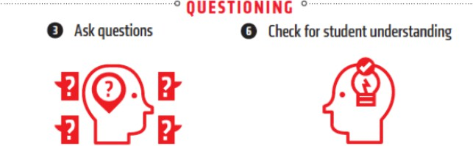

Effective Questioning and Classroom Talk is essential to develop learning & higher order thinking, promoting imagination, speculation, creative thinking & to pitch a suitable challenge level. This is where the quality of questioning is paramount. Questions can highlight misconceptions and challenge children to think deeper. The greatest value of questioning is that they force children to

practise retrieval; this strengthens and deepens memory hence the importance of high quality questioning. Although we encourage questions to be planned, we also encourage questioning to be responsive to what is happening in the lesson.
At Great Ponton, we ensure talk time is given to children to allow them to talk to other children and adults. We use talk partners to promote talk in all classrooms. Wait times are given to allow children to pause and review to enable the children to process the information. We are investing time in staff training to support effective questioning in the classroom as well as a graduated approach to high quality questioning and we encourage higher order questions to encourage deeper investigation of concepts.

Some effective questioning techniques that are used daily at Great Ponton can be seen in Appendix 3.

Monitoring levels of understanding (Core 10 – Keeping on task)

We recognise the importance of ensuring that levels of understanding of taught concepts are secure before learning is moved on in lessons. To achieve this teachers ask carefully crafted questions, using a range of techniques as seen in appendix 3, and carefully monitor pupils responses to questions and tasks. Teachers give careful consideration towards the deployment of adults in the room and how this supports the ongoing assessment process.
Once misconceptions and gaps in learning have been identified within or after lessons we aim to maximise the impact of additional adults in the school.

- TAs are utilised to support the marking process to enable pupils to complete targeted questions
- They deliver pre teaching and corrective teaching tasks with pivotal pupils as directed by class teachers.
- TAs are deployed to work with specific pupils during lessons, both within and outside the classroom to consolidate and extend children’s learning.

Assessment for Learning
Assessment is an integral part of effective teaching and learning. Teachers use a range of formative assessment strategies, including questioning, observation, discussion and review of pupils’ work, to identify strengths, misconceptions and next steps. Assessment information informs future planning and enables teachers to adapt teaching to meet pupils’ needs.

Provide Models and Scaffolds (Core 10 – Explicit modelling)
Research has found that successful teachers spent longer guiding children’s practice through explanations and modelling than less effective teachers. After children have been exposed to high-quality explanations and models, they can begin to be involved in the knowledge recall or procedural process. This is where children begin to take ownership over parts of the task with the support of the teacher as a scaffold or guide.
At Great Ponton, we understand the importance of providing all children with scaffolds despite their level of ability to help guide their responses or help them recall information. This could be in the form of a help-sheet, sentence starters, word mats, writing frames or physical resources. We have high expectations and with these scaffolds and expect all children to take part in the learning.

The input phase is punctuated through clear modelling of whatever it is that we want the children to be able to do. Opportunities for modelling key learning points are carefully considered in every lesson and clearly outlined within lesson planning. Through ensuring periods of input are followed by rehearsal activities, teachers ensure that children are given opportunities to apply and deepen their understanding before the lesson moves on. For example, a teacher might be modelling how to use embedded clauses within sentences. She might ask the children to work with a partner to construct a sentence together on a whiteboard before continuing with further instruction.
Phase Three - Time for pupils to complete guided or independent practice
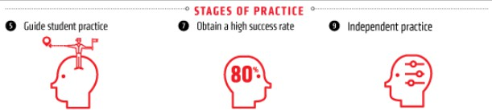

Guided Practice
More effective teaching occurs when you give more time for guided practice, this is directly linked to children spending more time asking questions, more time checking for understanding and using more worked examples. The idea is that if learners are going to be successful in becoming confident and independent within a certain knowledge area, the teacher needs to make sure they are forming strong schema early on. Therefore, at Great Ponton, we ensure learners spend additional time rephrasing, elaborating and summarizing new material in order to store material in the long term memory. All children need to practice, however, practice must be guided so that the chance of forming misconceptions is minimised. If children have any misconceptions, then these misconceptions are unpicked, and retaught where appropriate.

At Great Ponton, guided practice is where learning activities involve thorough explanations, high frequency, short answer questions or simple tasks where the teacher and learners are engaged interactively, with plenty of modelling, corrective or affirming feedback and aspects of re-teaching where gaps remain. An example of this would be the ‘we do’ part of a lesson.

Within lessons and over a series of lessons within a teaching unit, children are given time to practice using new knowledge and skills. Research recognises independent practice as a vital part of learning because it provides pupils with the much-required opportunity to complete a procedure or activity over and over. He identifies ‘overlearning’ as necessary for pupils to become fluent or automatic in a skill. When children become automatic in a process or skill, they free up their working memory which can be used to apply their learning to new contexts. This is when pupils can consolidate their learning.

Independent Practice
At Great Ponton, we consider the following when planning effective independent practice.

- Planning the right practice activity (during independent practice, pupils should work on the same material covered during guided practice to give them an opportunity to consolidate their learning).
- Providing further guides and scaffolds
- Using collaborative practice to best effect
- Gradually removing scaffolding

The more children practise the material, the stronger the retrieval strength becomes. Without enough independent practice, children will find it more challenging to recall information or procedures at a later stage as the retrieval strength of the new material won’t be as strong. An example of this would be the ‘you do’ part of the lesson.
Phase Four - Review learning and plan next steps

The emphasis in this phase is reviewing what has been learned and reflecting on how and why it has been learned. Review is key to memory, and we understand that it is important not just to confine it to the end of the lesson. At Great Ponton Primary we recognise that good teaching requires teachers to constantly refer back to the milestone throughout the lesson and reinforce prior learning. This is a very important aspect of the lesson and the learning process in general as large amounts of information can be forgotten quickly by children.
We recognise that when teachers summarise what has been learned, the effect on children’s memories can be restricted. However, when the children are involved in identifying what they have learned in the lesson, their memories will be significantly boosted.

Teachers provide opportunities for pupils to reflect on their learning, identify successful strategies and consider how these can be applied in future learning. Developing pupils' metacognitive skills helps them to become increasingly independent and self-regulated learners.

Effective teaching across Great Ponton Primary is characterised by the following features. Teachers will use their professional judgement to apply these principles appropriately across different subjects, age groups and learning contexts

Effective teaching is built upon planning that has clear learning outcomes.
- Planned units of work centre around identified milestones which are recovered regularly throughout the year
- Intended milestones create the right level of challenge and are built upon prior learning
- All milestones are written up and shared orally in child friendly language

Effective teaching includes well-planned success criteria that support pupils to understand how success will be achieved. (Core 10 – Keeping on task)
- All children are clear about how they will achieve the intended milestone through clear modelling and discussions of strategies
- Toolkits are displayed (in literacy lessons) for the children to follow, or drawn up with the children, during the lesson where appropriate
- Teachers ensure that the success criteria outlined within toolkits are revisited regularly throughout the lesson
- Teachers may refer to individual children’s work during lessons to illustrate examples of good practice and successful use of success criteria

Effective teaching is responsive to the needs of different groups of learners.
All groups of learners are challenged appropriately in lessons, including the needs of pupils with SEND. More information can be found in the SEND policy. This is achieved through the use of scaffolded questioning, and planned tasks which support different depths of learning. Intended learning outcomes are the same for all children. This is to ensure that all our pupils are able to access the same learning. Class teachers are responsible for adapting support through questioning, scaffolds, resources and adult guidance to enable all pupils to access learning successfully.
Teachers maintain high expectations for disadvantaged pupils and actively seek to remove barriers to learning through careful planning, responsive teaching and targeted support.

Adaptive Teaching

At Great Ponton, we believe that all pupils should access an ambitious curriculum.
Rather than lowering expectations for some pupils, teachers adapt their teaching to ensure all learners can achieve success.

Adaptive teaching may include:

- Pre-teaching key vocabulary.
- Additional modelling and worked examples.
- Carefully structured scaffolds.
- Flexible grouping.
- Adapted questioning.
- Targeted adult support.
- Additional rehearsal opportunities.
- Removal of scaffolds over time to promote independence.

The expected learning outcome remains ambitious for all pupils. The adaptation lies in the support provided rather than the end goal.

This approach ensures that all pupils, including those with SEND and disadvantaged pupils, can engage successfully with the curriculum.

Effective teaching provides regular opportunities to develop and strengthen children's oracy. (Core 10 – Oracy and vocabulary)
- Through the use of Talk Partners, pupils are provided with regular opportunities to think and share ideas together to develop their learning
- Children are expected to answer in full sentences when responding to questions.
- Children are encouraged to draw upon key vocabulary in every lesson.

All pupils receive regular and clear …. feedback which enhances their learning
- The school’s policy for providing feedback and responding to children’s work is embedded in everyday practice and is used to support and inform teaching and learning
- All pupils are clear about what they need to do in order to improve their work
- Marking is sharply focused against the intended learning outcome and identifies next step prompts
- Pupils are given regular time to respond to marking prompts and this is built into lesson planning and facilitated through adult support.
- Live marking – The use of live marking in lessons ensures that misconceptions or observations and assessments are quickly addressed either on the same day or the next morning via post teaching interventions.

Learning is enhanced through the use of …. consistent behaviour and classroom management approaches

Positive behaviour management systems are designed to minimise the time spent on behaviour management and maximise the time spent on learning. All our staff must consistently apply the same approaches which are clearly outlined in the behaviour policy. These approaches are underpinned by our values of Curiosity, Compassion, Courage and Community.

All pupils are …. actively engaged in their learning (Core 10 – Keeping on task)
- Pupils are actively engaged during all parts of the lesson – teachers take into account
children’s concentration span and ensure pupils are not sitting passively for long periods.
- Mini whiteboards are used for short bursts of activity, to develop and check for understanding and to ensure children are active and engaged during the lesson.

Leadership Responsibilities

School leaders will:

- Provide high-quality professional development.
- Model effective classroom practice.
- Support staff through coaching and feedback.
- Monitor implementation proportionately.
- Celebrate effective practice.
- Provide additional support where required.
- Ensure that monitoring focuses on improvement rather than compliance.

This creates shared accountability.

Monitoring and Evaluation

The implementation of this policy will be evaluated through:

- Learning walks.
- Professional discussions.
- Pupil voice.
- Work scrutiny.
- Assessment information.
- Staff feedback.

Evidence gathered will be used to inform future professional development and policy refinement.
The primary purpose of monitoring is improvement and support.

Classroom Environments

The surroundings in which children learn can greatly influence their academic performance and wellbeing in our school. The better the school looks, the more it inspires the people inside it. A well cared for and organised classroom and school can make pupils feel that they want to achieve and how they themselves are perceived is important.
At Great Ponton Primary we believe that classrooms should be calm, well organised learning spaces. Pupils need to know how to access resources and respect the classroom environment. To ensure a
sense of consistency across the school the following points below need to be taken on board in each classroom.

- The values of Curiosity, Compassion, Courage and Community are displayed in all learning environments
- A writing wall under the headings: Exploring, Building and Inventing (see below)
- A Read Write Inc sound chart
- A maths learning wall that reflects current learning
- Classrooms are tidy, labelled and organised. Pupils take responsibility for ensuring their classroom is a pleasant and safe place to learn.
- Pupils are taught to respect equipment and resources

The Literacy Working Wall

Exploring | Building | Inventing
Immersing ourselves in the text. Understanding and gathering evidence about the text and genre. Collecting further information to support this understanding. | Giving children the skills to be able to write in the genre -unpicking the final tool kit. Modelling key skills. Generating and experimenting with writing. | Using the skills they have gathered to plan and write in the style.  Using a toolkit which embraces all the skills taught through the innovation stage, the children are now able to apply this for the final piece. No modelling as this can  now be levelled.

Reading the text  - Reading to the children  - Pictures  - Text on the smartboard  Story/Text Mapping  - Teacher created  - Children’s examples  - Story boards  - Mind maps  - Ordering and sequencing  Role play  - Freeze framing  - Hot seating  - Conscience alley  - Photographs to evidence  - Puppets  - Videoing  Using the environment for imagination  Pictures stimulus Music stimulus  Other texts on the same theme  Vocabulary  - Wow words  - Technical vocabulary  - Genre specific  - Magpieing  - ​  Language games  Book Talk  - Children’s responses to the text  - ​  Collecting Information  - Note taking  - Data capture | Boxing up the text/genre Creating a class toolkit Modelling  Shared writing  Text Shape  - Pictures  - Investigating the structure of the text  - Comparing openings  - Comparing endings  - Identifying the build up  - Changing the atmosphere  - Developing and describing settings and characters  - Non-fiction – writing introductions, summaries, headings, sub-headings etc.  Sentence Structure  - Lengths – simple, complex, compound, embedding clauses.  - Connectives and conjunctions  - Sentences for effect  Developing Vocabulary  - Adjective  - Adverbs  - Adjective and adverbial phrases  - Synonyms and antonyms  - Changing word order  Punctuation Development | Stimulus  - Picture  - Title  - Question  - Word bank Teacher Example Genre specific tool kit  Individual Planning  - Story map  - Boxing up  - Planning grid  Independent application

Appendix 1 – Core 10 principles of practice at Great Ponton

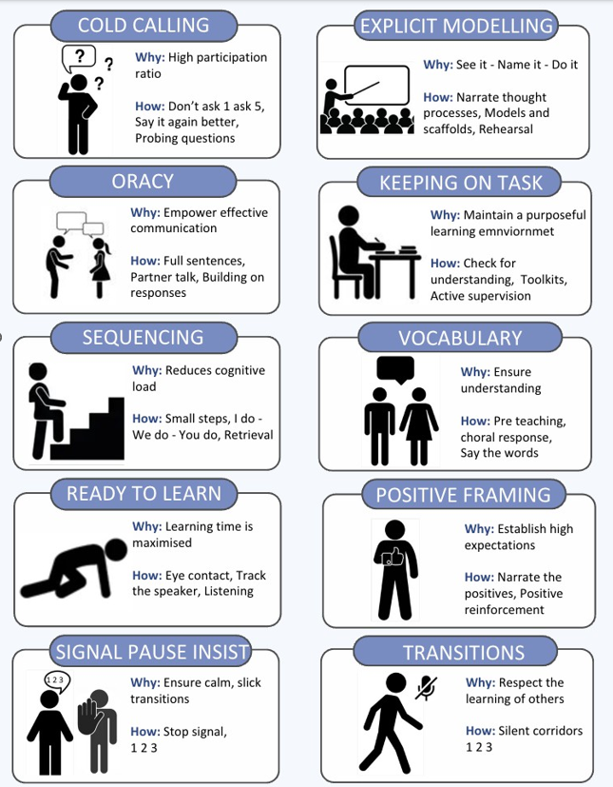

Appendix 2 – Retrieval strategies at Great Ponton

Cops and Robbers  Cops – Students write as much as they can from memory about a certain topic.  Robbers – Students get out of their seats, sharing and stealing ideas from their peers. | Retrieval Practice Placement  Key questions such as: What keywords did you use last lesson?  State 3 facts from last lesson Explain a key concept from last lessons  Ask your partner 3 questions based on… | Retrieval tennis  Pairs take turns to recall facts/information that is relevant to the topic. They can not repeat themselves or say something that their partner has already said.
Retrieval relay race  4 box grid. Box 1 – Write as much as you can remember about our topic. Box 2 – A peer writes what they can recall.  Repeat for boxes 3 and 4 but no one is allowed to repeat what  has already been written. | Retrieval rockets Countdown 5 to 1 to launch the rocket. At each of the 5  steps, pupils must recall a fact. | Retrieval baskets  Throughout the lesson, write questions based on the content of the lesson and store in a basket. These questions then get asked in future lessons via cold calling techniques.

Appendix 3 - Questioning techniques at Great Ponton

Questioning techniques
Cold call | No hands up or calling out.  Asking everyone – select who answers.
No opt out | If students get an answer wrong or don’t know, go back to them to check that they  now
Check for understanding | Ask selection of students to relay back what they have understood about the  question under discussion.
Probing questioning | Make each question and answer exchange a mini dialogue, probing to explore  student’s understanding.
Say it again better | Accept students’ first half-formed responses but then help them to reframe a better  more complete response.
Choral response | Use techniques like mini whiteboards to provide simultaneous responses from a  whole class.

Cold calling techniques
Pre call | This is when you tell one or more students that you will ask them to respond after you’ve given an explanation, read a passage or watched a video. Ok, John and Sabrina, after the video, I’d like you to summarise the key points for us. This gives them that extra bit of notice to prepare. Other students know they too could be cold called afterwards but John and Sabrina get some prep  time.

Batched cold call | When you tee up a number of students to answer in one go. Right, now I’ve explained my  examples, I’d love to hear your versions. I’ll start with Michael, then Daisy, then Samuel. You then ask them one by one. It gives Michael and especially Daisy and Samuel a heads up. They can get ready. Any sense of ‘gotcha’ is removed entirely.
Rehearse and affirm | This is where, first, you have given all students an opportunity to share their answers non-verbally through a means you can see such as whiteboards (Show me!); You select answers that are correct or interesting and then cold call the students to ask them to expand. Robyn, what a great answer. Could you explain how you came to that conclusion? Jason, well done, B is the correct answer. How did you know that?  This technique has the effect of giving Robyn and Jason confidence in their understanding before they give their answer publicly. They already know they are right. It’s a technique that is great for the less confident students; you build them up by asking them to explain their good ideas or  correct answers you’ve already seen – rather than them feeling it’s a risk offering answers at the point when they are still unsure.
Don’t ask  one, ask five | This is an important element of our retrieval practice. When checking particular pupils have understood and remembered a particular concept, such as ‘irrigate’ or ‘irrigation’, we don’t just choose one pupil to check to understanding. Adults will choose five in quick succession so that all pupils are doing the work of retrieval in their heads because they know they might be asked.  We aim to take a sentence and keep rephrasing the question in different ways so pupils have to use the words in different combinations in a full sentence.

